Did You Know?
Facts, Figures & Folklore about the Pilgrims & the First Thanksgiving

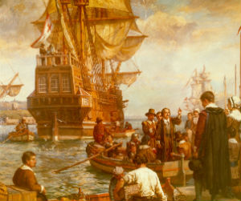

Did you know that the Pilgrims trip to the New World aboard the Mayflower lasted 65 days? It was a cold and damp journey, and since the ship was wooden, passengers were not allowed to light a fire for warmth or for cooking their food.

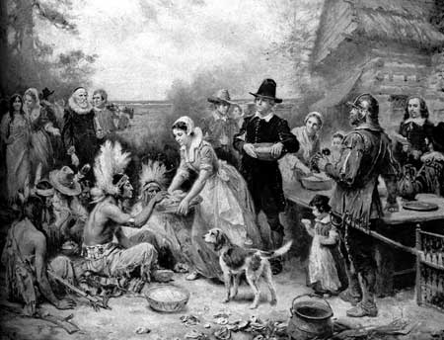

Did you know that half of the 110 Pilgrims who had left England in 1620 survived that first year in the New World? In their second year, however, the Pilgrims flourished with plentiful food sources, thanks in large part to the friendship and guidance of an Abnaki Indian named Squanto.

Did you know that the first Thanksgiving took place in December 1621, when the Pilgrims held a three-day feast in Plymouth Rock, Massachusetts to celebrate their bountiful harvest?

Did you know that the first Thanksgiving feast was celebrated during the Pilgrim's second year in the New World? During the first year, the Pilgrims were nearly decimated by the brutally cold winter.
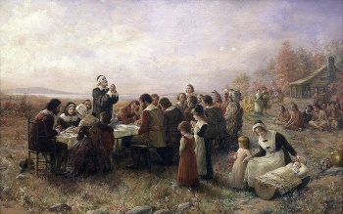
Did you know that the first thanksgiving celebration was held in the fall of 1621 by the proclamation of Pilgrim Governor William Bradford? He invited the neighboring Native Americans to join with the colonists in the three-day celebration, which featured games, races, bow and arrow competitions, and of course feasting of the bounty of the fall harvest.

Did you know that Thanksgiving didn't become an official national holiday until more than 200 years later, when in 1863 President Lincoln proclaimed the last Thursday of November a national day of thanksgiving?

Did you know that as many 107 million American homes will celebrate Thanksgiving this year?

Did you know that US Presidents issue an annual Thanksgiving Proclamation declaring the 4th Thursday of November as Thanksgiving? While President George Washington was the first US President to issue a Thanksgiving Proclamation, not all following Presidents followed the custom. In 1863 President Abraham Lincoln proclaimed a national Thanksgiving Day to be celebrated on the final Thursday of November. In 1939 President Franklin D. Roosevelt declared that Thanksgiving would be celebrated on the fourth Thursday in November and in 1941 the US Congress passed a law officially establishing the celebration of Thanksgiving as the fourth Thursday in November.

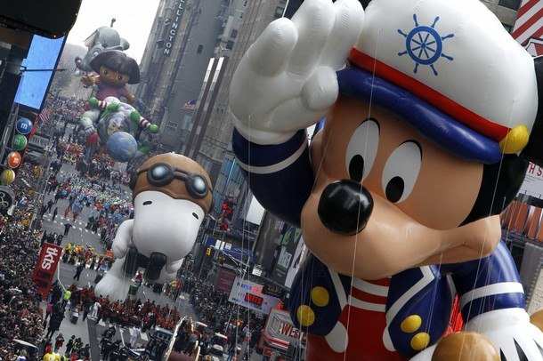
Did you know that it is tradition for US Presidents to issue a pardon to the White House Thanksgiving Turkeys? Since about 1947 the National Turkey Federation has presented the President of the United States with one (and in recent years - two) live turkey(s) in a ceremony known as the National Thanksgiving Turkey Presentation. The live turkeys are pardoned and live out the rest of their days on a farm or, since 2005, sent to either Disneyland in California or Walt Disney World in Florida, where they serve as the honorary grand marshals of Disney's Thanksgiving Day Parade. While it is commonly believed that this pardoning tradition began with President Harry Truman in 1947, the Truman Library has been unable to find any evidence for this. The earliest Thanksgiving Presidential Pardon on record is with President George H. W. Bush in 1989.

Did you know that the most popular Thanksgiving dinner includes a menu of turkey, cranberries, sweet potatoes and pumpkin pie? Then it's only fitting that Americans raise over 256 million turkeys. The biggest producer of turkeys is Minnesota, followed by North Carolina, Arkansas, Virginia, Missouri and California.

Did you know that U.S. turkey farmers also raised just over 144,000 organic turkeys in 2005.

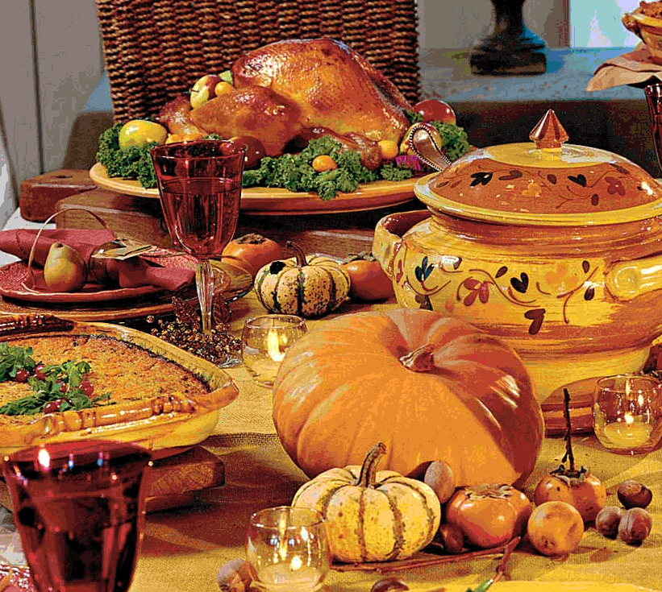
Did you know that there is no historical evidence that the first Thanksgiving included turkey, which is, of course, the centerpiece of today's Thanksgiving meal? There was, however, mention of wild turkeys in a book written by Pilgrim Governor Bradford.

Did you know that the average Thanksgiving turkey weighs 15 pounds? Hens can range from 10 to 18 pounds, while toms can be as large as 25 pounds. The most traditional way to prepare a turkey is to stuff and roast it, although some chefs -- particularly in the south -- swear by deep frying their birds.

Did you know that Americans raise 649 million pounds of cranberries, 1.6 billion pounds of sweet potatoes, and 998 million pounds of pumpkin?
In addition to domestically grown and raised Thanksgiving food, the U.S. also imports $5.2 million worth of live turkeys from Canada, $2.2 million worth of cranberries (also from Canada), and $2.3 million dollars worth of sweet potatoes -- from the Dominican Republic.
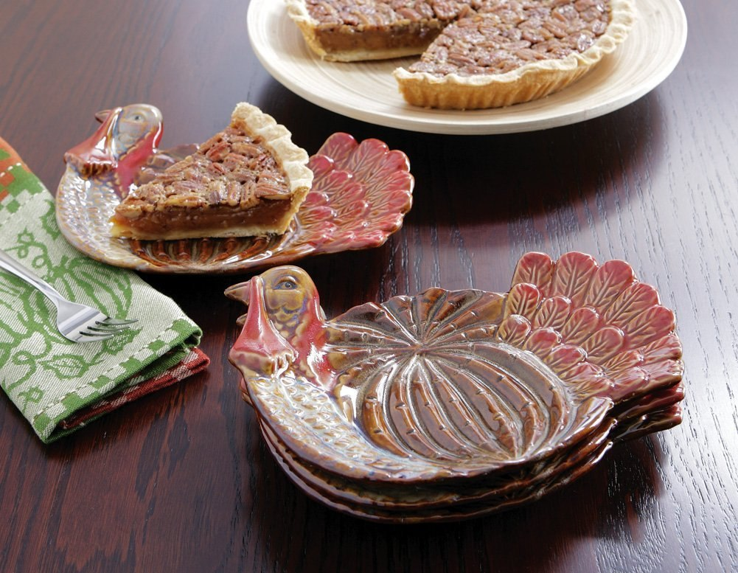

Did you know that there are at least three American towns named after Thanksgiving dinner's main course? There's Turkey, Texas, with 496 residents; Turkey Creek, Louisiana, with 357 residents, and Turkey, North Carolina, with 267 residents. There are also eight places and townships named Cranberry, and 20 places named Plymouth, after the location of the first Thanksgiving.

Did you know that the first National Football League's Thanksgiving Classic game was played in 1934, when the Lions hosted the game as a gimmick to get people to go to Lions football games?

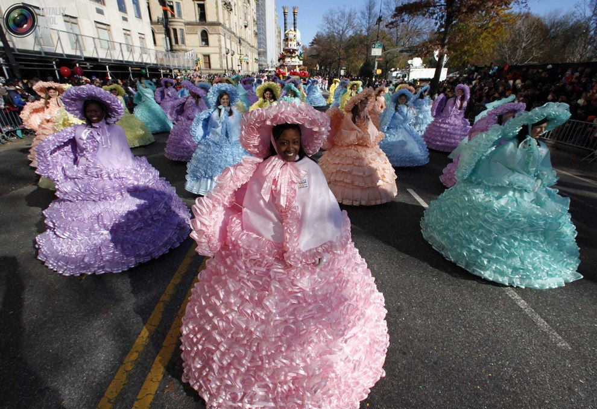
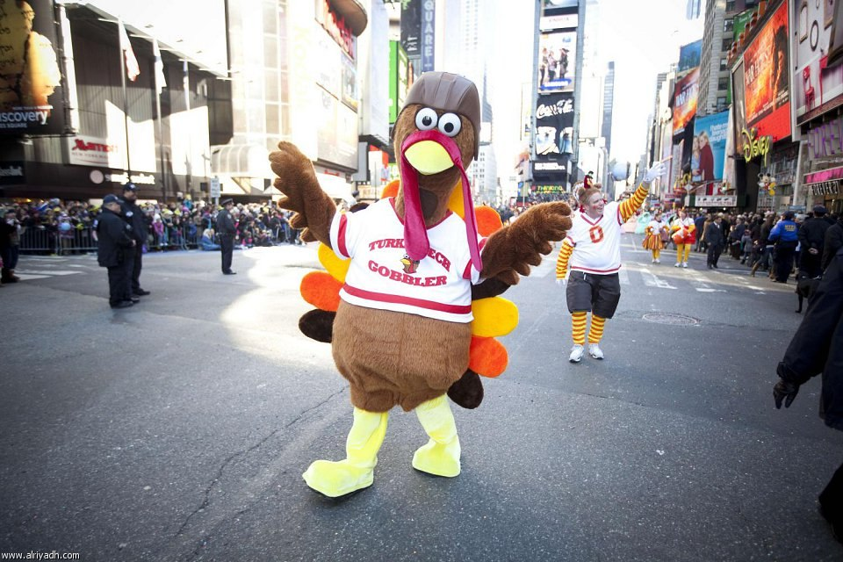
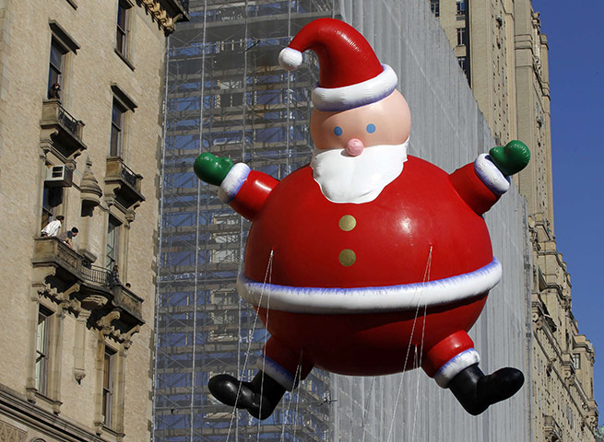
Did you know that while there are many "Thanksgiving Day" parades held across the country, the most famous has to be the Macy's Thanksgiving Day Parade in New York City? The Macy's Thanksgiving Day Parade is held annually every Thanksgiving Day and is televised nationally by NBC. The parade features parade floats with specific themes, scenes from Broadway plays, large balloons of cartoon characters and TV personalities, and high school marching bands. The float that traditionally ends the Macy's Parade is the Santa Claus float, the arrival of which is an unofficial sign of the beginning of the Christmas season.

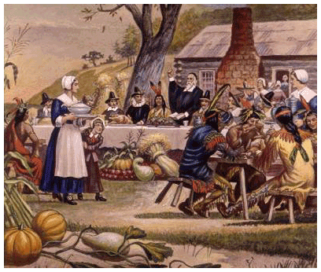
Did you know that for many Native American people, Thanksgiving is cause for mourning rather than celebration?
Although the First Thanksgiving included the Pilgrims' Native American neighbors, that spirit of cooperation did not last long between the native people and the colonists.
The land and lives of the native people were pillaged and destroyed countless times during the early history of the United States of America. Racism and bigotry persist until this day.
As a result, Thanksgiving has taken on greater historical significance for many Native Americans, who view that First Thanksgiving as the beginning of centuries of oppression and discrimination.

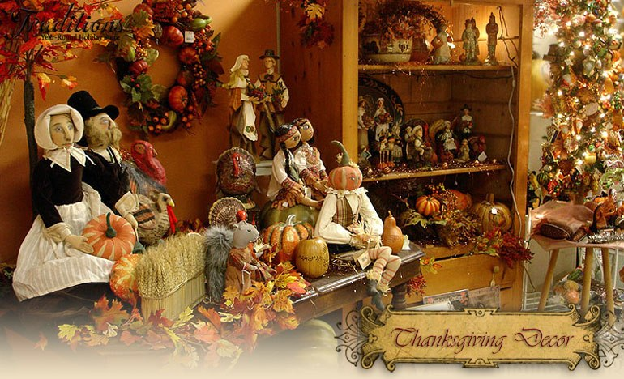

Did you know that Black Friday -- the day after Thanksgiving, which is widely touted as the biggest Christmas shopping day in America -- is actually not the biggest shopping day?

In fact, the Saturday before Christmas has historically been the largest volume shopping day. Black Friday ranks anywhere from second to fifth in Christmas shopping days.

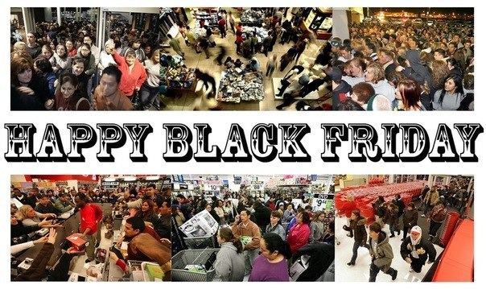

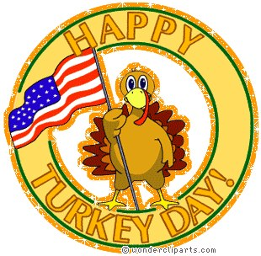
The Thanksgiving Turkey
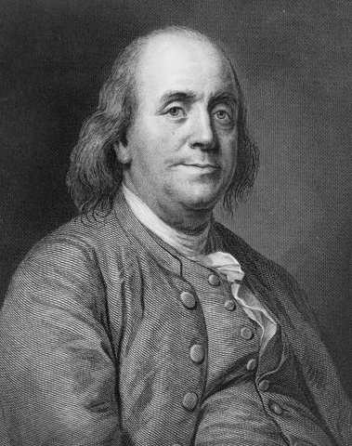
"I wish the Bald Eagle had not been chosen as the representative of our country: he is a Bird of bad moral character: like those among Men who live by Sharping and Robbing, he is generally poor and very often lousy.
The Turkey is a much more respectable Bird and withal a true original Native of North America"

Benjamin Franklin

Of all the Thanksgiving symbols the Turkey has become the most well known. The wild turkey is native to northern Mexico and the eastern United States.
The turkey has brown features with buff-colored feathers on the tips of the wing and on the tail. The male turkey is called a Tom and, as with most birds, is bigger and has brighter and more colorful plumage. The female is called a Hen and is generally smaller and drab in color.

The Tom turkey has a long wattle (a fleshy, wrinkled, brightly colored fold of skin hanging from the neck or throat)at the base of its bill and additional wattles on the neck, as well as a prominent tuft of bristles resembling a beard projecting downward from its chest.

The turkey was originally domesticated in Mexico, and was brought into Europe early in the 16th century. Since that time, turkeys have been extensively raised because of the excellent quality of their meat and eggs. Some of the common breeds of turkey in the United States are the Bronze, Narragansett, White Holland, and Bourbon Red.

Though there is no real evidence that turkey was served at the Pilgrim's first thanksgiving, in a book written by the Pilgrim's Governor Bradford he does make mention of wild turkeys. In a letter sent to England, another Pilgrim describes how the governor sent "four men out fowling" returning with turkeys, ducks and geese.

